
SATISH CHANDRA MEMORIAL SCHOOL
ACADEMIC SESSION: 2025-26
CLASS VII
CASE STUDY & ASSERTION-REASON QUESTION BANK
SEGMENT: ADDITION & SUBTRACTION
CHAPTER 01: INTEGERS

CASE STUDY 1

Solanki lives in a small house beside a sea, which is 100 m above the sea level. Every Sunday she goes there to see a shoal of fish which naturally moves around 1 m below the sea level. From her house a mountain can be seen which is 3,120 m above the sea level and it needs 750 m to travel by a boat to reach at the base of the mountain.
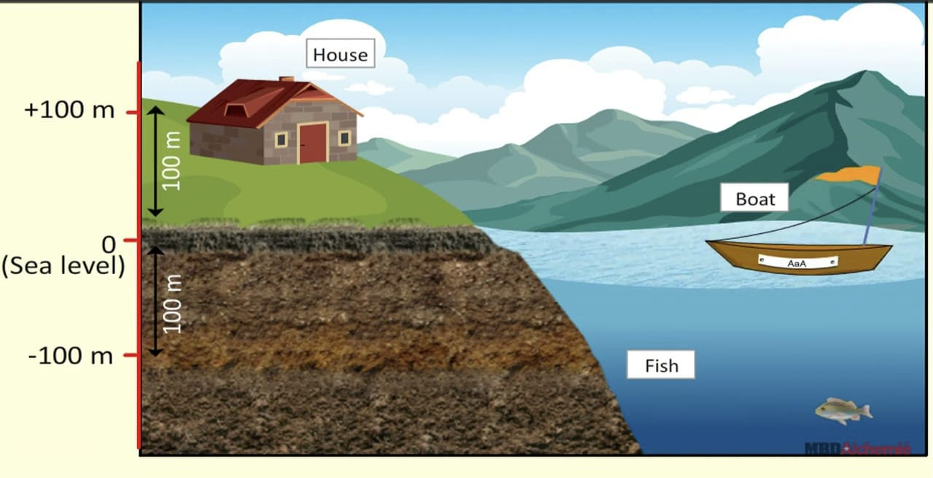
1. . What is the vertical distance between Solanki’s house and the mountain?
2. If the shoal of fish move up for 0.5 m and then again move down for 0.25 m then how far the shoal of fish will be from Solanki if she stands at the sea level?
3. One morning Solanki started climbing from the base of the mountain and covered one-tenth height of the mountain. How far was she from the apex of the mountain?

CASE STUDY 2

In a helicopter, Virat is 200 feet above sea level and in a submarine, Rohit is 150 feet below sea level. The speed of the helicopter is 150 feet/sec and the submarine goes 3 feet/sec.
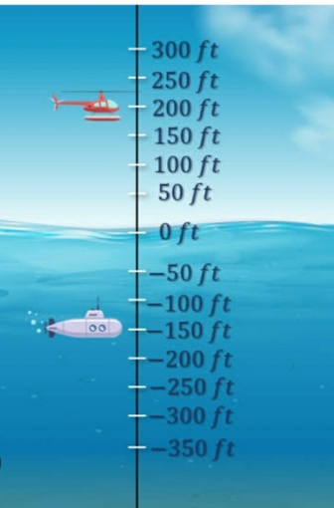
Q(1). How far Virat and Rohit were from each other initially?
Q(2). If the helicopter moves down and the submarine moves up for 1 sec and 15 sec respectively and stop there then how apart will they be from each other?
Q(3). If the submarine moves up for 2 sec at 10 a.m then moves down for 4 sec at 11a.m again moves up for 5 sec at 12noon and finally moves down for 6 sec at 1p.m respectively then where will it be after moving down at 1p.m?
Q(4) Find the distance between Virat and Rohit if Virat moves up for 2sec then moves down for $\frac{1}{2}$ sec and Rohit moves down for 8 sec then moves up for 5 sec.

CASE STUDY 3

Aditya, Abhay, Kiaan and Harman decided to go for trekking Sandakphu to enjoy their summer vacation. So, they made a plan for 10 days tour. First they reached at NJP railway station by train. From there they took a taxi to Sepi. From there they started trekking the peak and found they were 8580 m above the base point.

- While trekking when Kiaan reached 2050 m, suddenly he got slipped from his position and moves down for 1270 m. How far is he then from the apex of the mountain ?
- As they climbed higher the temperature dropped by 2°C in every hour. What would be the temperature after 5 hours if they started their journey at 28°C?
- At the time of climbing down, Abhay was 200 m below Harman from the peak. If Harman was 300 m below the peak, how far was Abhay from the peak?

CASE STUDY 4

An atom consists of charged particles called electrons and protons. Each proton has a charge of +1 and each electron has a charge of -1. For a neutral atom number of protons is equal to number of electrons.
Ions are atoms that contain an uneven number of protons and electrons which results overall positive or negative charge. When an atom changes to a charged particle called ion if it loses or gains electrons. The charge on an ion is the charge on electrons plus charge on protons.
Ions are of two types, one is Cation and another is Anion. Cations are atoms that contain a positive charge and Anions are atoms that contain a negative charge.

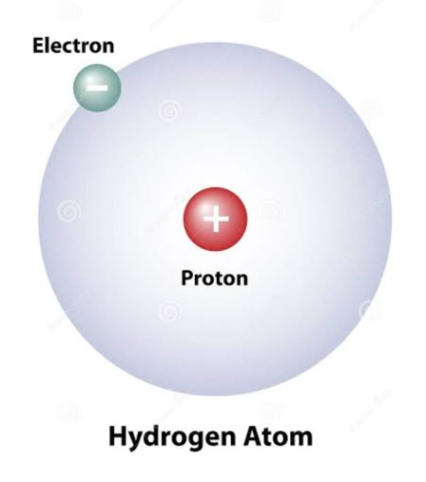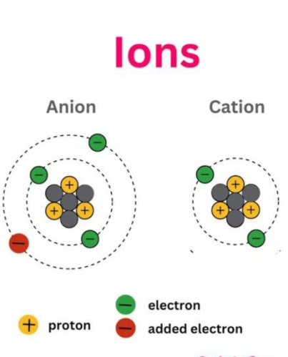

Name of Ion | Electron Charge | Proton Charge | Ion Charge
Nitrate |  | 32 | -3
Chlorite | -33 |  | +1
Acetate |  | 24 | -1
Ammonium | -10 | 11
Sulfate | -32 |  | -2

- Identify the electron charges of acetate in the above table.
- What would be charge of ion for ammonium?
- Calculate the charges of proton in chlorite.
- Find the number of electron charges for nitrate.

$$Assertion-Reason Based Questions$$

$$INSTRUCTIONS: All the questions given below are Assertion and Reason based$$
$$questions. Two statements are given, one labelled as Assertion and$$
$$the other is labelled as Reason. Select the correct options from$$
$$the codes \left(a\right), \left(b\right), \left(c\right), \left(d\right)as given below.$$
$$\left(a\right) Both Assertion(A) and Reason(R) are correct and Reason(R) is the correct explanation$$
$$of Assertion(A).$$
$$\left(b\right) Both Assertion(A) and Reason(R) are correct but Reason(R) is not the correct explanation$$
$$of Assertion(A).$$
$$\left(c\right) Assertion(A) is true but Reason(R) is false.$$
$\left(d\right) Assertion(A) is false but Reason(R) is true.$

- Assertion: Closure property under addition and subtraction states that the sum or difference of any two integers will always be an integer.

Reason: 5 + (-3) = 5-3 = -8

- Assertion: The additive inverse of a negative integer is positive.
Reason: The additive identity is 1.

- Assertion: (-76) + (-68) = - 144
Reason : When we add two negative integers, we get a negative integer.

- Assertion: Negative integers are always greater than zero.
Reason : Zero is less than any positive integers.

- Assertion: Additive identity property states that a × 1 = a
Reason : 5 + 0 = 5

